THE YOUTH INDIA
YOUTH VOICE OF INDIA
SAMAJ SEVA & ANIMAL CARE CENTRE

LOK SABHA ELECTIONS
JANUARY, FEBURARY & MARCH, 2019
Ruppees : 40/-
2019
HATE VS LOVE
CHOICE IS YOURS
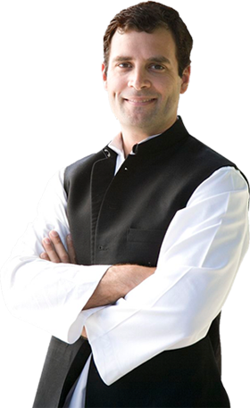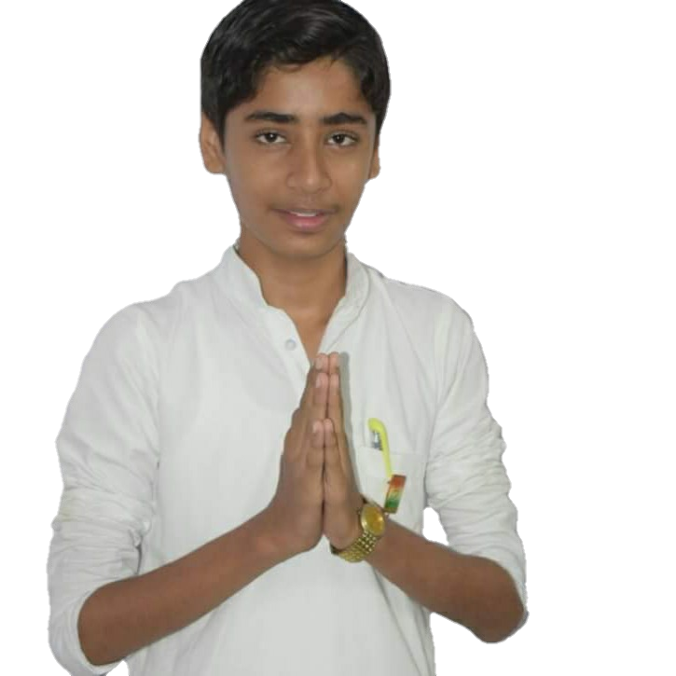

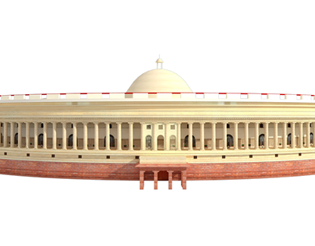

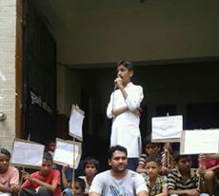
DEAR FELLOW SSACC MEMBERS,

We have to give our best to this elections. We have to spread the ideology of Congress & SSACC among the country. It is theway to do real fight. Our opposition will spread the hate among you but you should be calm and spread love not hate.
After these elections country will see their new prime minister & Iam confident that we will win!!
Yours Sincerely,
Jai Hind !!
MANNAT SHARMA
Election Commission of India announced the dates for the polling for upcoming general elections. Now only some time left pay your time and support for the Congress party.
Before some time I have announced the support to the Congress party for upcoming general elections because the destroying situation in the country. India is facing dark era and we have to give the dark era a growing position.
We have to remember the quotes of our founding fathers which lay foundation of the REPUBLIC, SOVERINGN, SECULAR AND INDEPENDANT country. But, they even not see that India can also face the dark era.


FROM EDITORS DESK
Salt march or Dandi March completed its 89th Anniversary on 12th March. People remembered contribution of Mahatma Gandhi on this movement. SSACC President call it historic movement while Congress President Rahul Gandhi remembered Mahatma Gandhi. Former President of SSACC Shri. Satya Prakash Sharma remembered the Salt March as historic step in Independance of India. SSACC President Mannat Sharma said that this step has give negative prospect to the British Economy.
While Remembering Dandi March’s Anniversary Election Commission of India released the dates for the General Elections at India. Election will held in 7 phases will start on 11th April and will end on 19th May. On 23rd May results will announced. Many opposition parties claim that Commission announced the dates to give profit in elections to Bhartiya Janta Party (BJP) and their allies. With the general elections the 4 states elections also held at Andhra Pradesh (175 seats), Odisha (147 Seats), Sikkim (32 seats) and Arunachal Pardesh (60 Seats). It will be the World’s biggest democratic election process.
Modi Government did not have any working experience and any achievement in their tenure. They have an election motto of Nationalism in the favour of the surgical strike happened at Balakot also named as the “Balakot Air Strike”. But we want to state that is armies operation and we will not give to profit to Modi Government. Taking credit of the armies operation is condemnable. Even, many political parties condemned that. On pulwama attack SSACC President Mannat Sharma paid tributes to them and give their families condolences. He also condemned this terrorist attack. Many Political leaders, parties and world leaders also paid tributes to the people martyr in the Pulwama attack.
Modi government does not have any achievement. The most of government assets given to the private industries and specially to the friends of the PM Modi. Rafale Scam is the example of this statement. Rafale Scam covers the scam of 1,30,000 Crore rupees. Congress President call it the direct profit deal to Anil Ambani. Modi government is totally failed to control the loss to the Indian Economy. In the starting of New Year 2019 many economist call black year for the Indian Economy. Even, for PM’s dream plan Swach Bharat Abhyan Government of India allotted 28% less funds in comparison of 2018. For Jan Dhan Accounts there are 6 Crore accounts which even not have the money in their accounts. In UJWALA YOJNA their are 1.2 Crore womens who did not apply for 2nd time cylinder. For this all we have arranged article this time.
The Politicalisation of martyr of soldiers died at the Pulwama Attack and of BALAKOT AIRSTRIKE is condemnable. We together condemned that. Our Organization always stand against this anti-national activity by the National Party who also in power at India. We also want to clear that it is operation conducted by the Army not by the BJP or PM Modi. SSACC Vice President call the PM’s statement on it nonsense, She also said where is inquiry against the people who were involved. Where are you Prime Minister? Satya Praksh Sharma added to his statement.
After all of this Government of India passed Reservation act for the upper backward classes of 20% on last day of Session. While talking to the Youth Nation Mannat Sharma at parliament house
THE YOUTH INDIA
Youth Voice of India
PRINTED IN ENGLISH

SAMAJ SEVA & ANIMAL CARE CENTRE
EDITOR
MS. NIDHI SHARMA
EDITORAL BOARD
SHRI. PARV SHARMA
MS. NAINA SHARMA
I/C BY ORGANIZATION
SHRI. NIRMAL NAYAK
PUBLISHED BY:
THE YOUTH INDIA NATIONAL COMMITTEE OF SSACC, 373, SHAHPUR JAT, NEW DELHI – 110049
PHONES: +919560 Mail: livetyi@gmail.in Website: www.officeofmannat.wix.com/youthindia
SUBCRIPTION CHARGES
One Years: 160/-
Two Years: 320/-
Three Years: 480/-
Five Years: 800/-
Note: The Youth India is every 3 Months magazine, published by every 3 Months. Please note delivery charges are 50/-

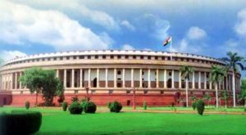Lets take highlight of Achivement of UPA Government:
* Education - India has achieved "near universal education" at the primary school level due to Right to Education and the dropout rates have also decreased. The outlay for education has been constantly increased. Central universities increased from 17 to 44 during 2004-13.
*Farmer welfare - Minimum support prices (MSP) for wheat and paddy has been doubled since 2004, while MSP for other grains have increased three fold. More than 650 lakh farmers were financed by the banking system during 2012-13. The new Land Acquisition Act will provide livelihood rehabilitation and financial benefits for the affected people.
*Food security- There has been a three-fold increase in food subsidy during UPA tenure. The Food Security Act will entitles 35 kg of food-grains per month and other families for 5 kg per person at subsidised rates.
*Rural employment- The Mahatma Gandhi National Rural Employment Guarantee Act (MGNREGA) is the largest welfare scheme of its kind in the world started in 2006. Wages given under the scheme per day have almost doubled from Rs.65 to Rs. 128 since the launch of the scheme. In 2012-13, the scheme provided employment to over 4.98 crore households, generating more than 213 crore person-days of employment.
*Healthcare- Consistent investment in public healthcare showed reduction in infant and maternal mortality rates, while life expectancy has improved. Absence of new endemic polio case for the last three years.
*Social security for special sections - There has been ten-fold increase in the expenditure on minorities since 2004-04.
*Economic growth - Per capita income in India has grown three fold since UPA came to power. The average GDP growth during the period of UPA government has been 7.7 percent despite two global slowdowns.
*Infrastructure - More than 2 lakh km of new roads have been added to the rural road network. Allocation for Pradhan Mantri Gram Sadak Yojana has increased by 88 percent in the 12 th Five Year Plan.
*Poverty reduction - Average decline in poverty was two percent per annum.
*Direct benefit transfer and Aadhaar card- The UID has issued more than 51 crore Aadhaar cards giving people access to direct benefit transfer in 184 districts.
*Development of Northeast : Internal security has improved and the growth rate in north-eastern region is now higher than national average. Northeast growth rate is 9.9 percent compared to national average 7.4 percent.
*Governance and transparency - Right to information, second administrative reforms commission, and e-governance ensured transparency. Among the anti-corruption measures, the government was able to
CONTENTS
bring the Lokpal Act, as also the Whistle Blowers Protection Bill, Grievance Redressal Bill, and Amendment to Prevention of Corruption Act.
*Security of women and children - The law has been amended to provide stringent punishment for sexual offences against women and children. The government has also passed the Protection of Children from Sexual Offences Act, 2012. TheWomen Reservation bill has been passed by the Rajya Sabha.

JANUARY, FEBRUARY & MARCH, 2019
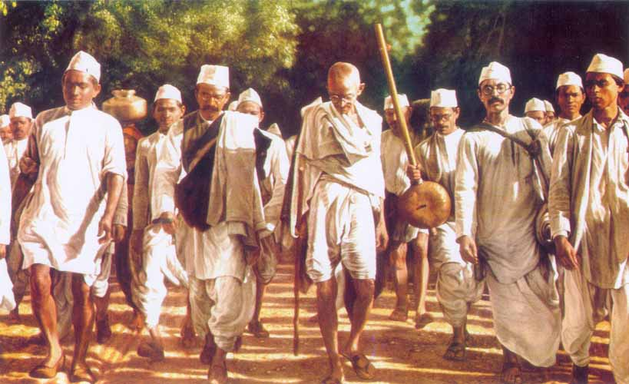
NATURE DIARY
- Water : An important Resource – 19
REMEMBERING IDEALS
- Remembering Rajiv – 23
TRIBUTES
- Tributes
LETTERS TO EDITORS
- Letters to Editors - 25
PRESS RELEASE
- Press Release by SSACC
SATYA DIWAS, 2018

BIG STORY
- Elections announced by ECI. – 6
- Mannat Sharma met Smt. Sonia Gandhi - 7
NEWS THIS MONTH
- News Bulletin - 8
HISTORY MOMENTS
- Dandi March: Movement which have critical involvement in Independence Era. – 9
POINT OF VIEW
- Achivement of UPA Government. By Nidhi Sharma - 11
- No Jobs till now. – 15
REPORT
- Dream 11 Prediction : A dark light for upcoming future – 17

BIG STORY
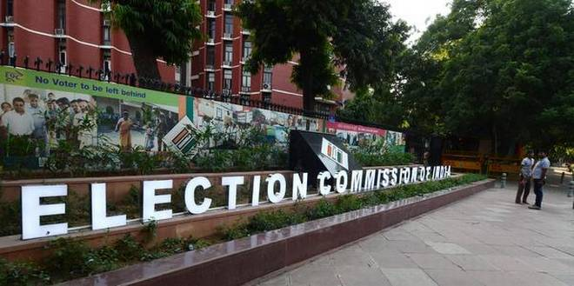

Elections Announced by Election Commission of India
HIGHLIGHTS:
- Elections will conducted in seven phases.
- With general elections 4 States Elections also conducted.
March, 2019

Election Commission of India announced Election dates for the upcoming General Elections 2019. The Election Commission of India (ECI) has announced final dates for the Lok Sabha elections 2019 during a press conference at 5PM on Sunday. The General Elections 2019 will be conducted in seven phases in April-May, beginning from April 11. The elections will be held for 543 seats on nearly 10 lakh polling booths across the country, while the counting of votes will take place on May 23. With the announcement of election dates, the Model Code of Conduct has come into effect from today, says Chief Election Commissioner Sunil Arora. At the press conference, CEC Sunil Arora said that nearly 90 crore people are registered as voters, of which 1.5 crore voters in the age of 18 and 19. The current Lok Sabha's tenure ends on June 3.
Intresting facts are that the ECI also conducted states election with the general elections which is mentioned at the starting of the magazine. ****
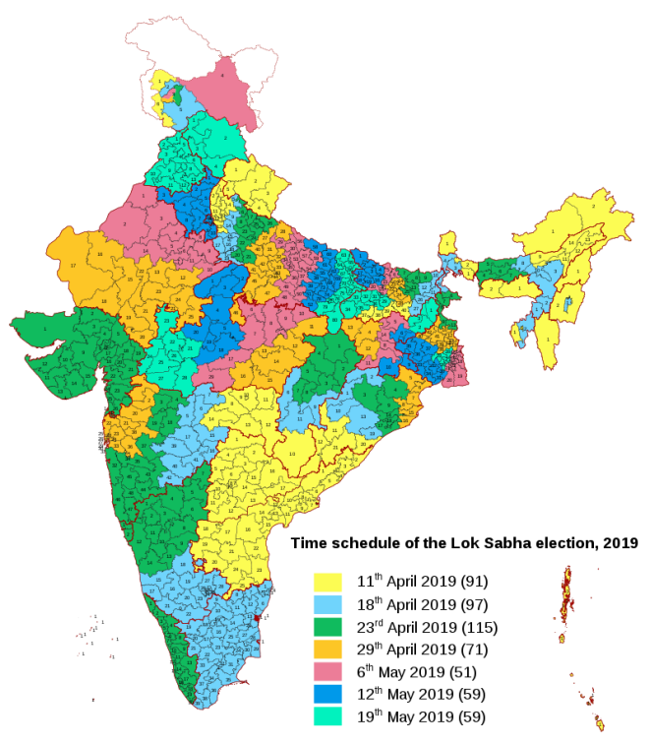
n
BIG STORY

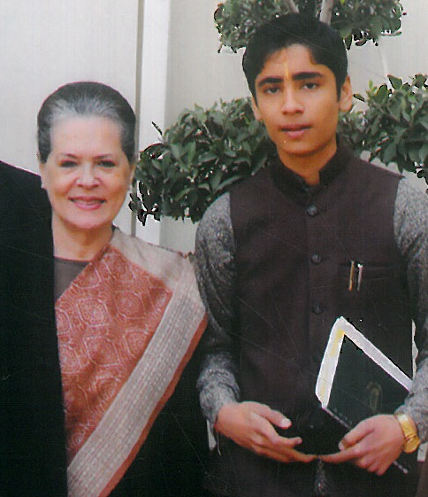

SSACC PRESIDENT MANNAT SHARMA MET SMT. SONIA GANDHI AT PARLIAMENT HOUSE
NEW DELHI | 14th February, 2019

SSACC President Shri. Mannat Sharma met Smt. Sonia Gandhi, Chairperson UPA at Parliament House. They both have talks on the upcoming elections and on several issues in the countries. Mannat Sharma raised the matter of the Dream 11 Prediction also.
Shri. Mannat Sharma tweeted photo and said that met the person who always smiles. According to the sources Smt. Gandhi and Shri. Mannat have half and hour meeting in the chamber of Mrs. Gandhi at Parliament house. While talking with the Tamil Nadu state Incharge of SSACC P. Swami nandan who present in the meeting said that both have positive intraction. As it is nature of Mrs. Gandhi, She send wishings and blessings for SSACC. The Youth India’s representatives ask them that what is issue he said “No Comments.
The Youth India also have talk with Mr. Sharma, he said in his statement that :
According to the sources with Shri. Mannat Sharma they tell that Mrs. Gandhi and Mr. Mannat have regular meetings and talks. Recently they have talks in January at Parliament House only. Recently, they both inquire about there well being at the Shakti Sthal while paying tributes to Smt. Indira Gandhi. In last meeting at birthday of Mrs. Gandhi Mannat sended her good wishings for her health. ****
I will not say on my meeting with Mrs. Gandhi. Already P Swami Nandan released the statement with The Youth India but can say that talk is positive.

NEWS THIS MONTH
- Priyanka Gandhi joins politics on 23rd January, 2019 officially. She is inchage of East UP. She also officially run account on different social media platforms.
- On 14th February, 2019 Pulwama attack happen at Jammu & Kashmir . 40+ died and 1 is suicide bomber.
- Election Commission announced dates for general elections and the 4 States elections.
- Jyotarditya Scindia, Congress MP nominated as the Incharge of Other regions of UP.
- Mayawati and Akhilesh decided to form the Allience against the BJP at Uttarpardesh.
- Former president of India Pranab Mukherjee send his wishings for the nEw Year to Hon. President of SSACC Mannat Sharma.
- Allies talks between Congress and AAP is over. The allies would be happen on 7 Seats of Delhi.
- Indian Army had done airstrike against the Pakistan at The balakot Region.
- Pakistan tried to cross the Air Space of India nad try to does the military operation on the Army places situated in the Indian Region.
- “We does the Air Strike on the Pakistan’s terrorist camps not on army iquiments” – Indian Army.
- Kailash Vijyawargiya appointed as the Inchage of BJP for west Bengal.
- Mannat Sharma can be on the Shirdi visit in the April month.
- Left leader Kanhaya kumar will be the candinate of CPI from the Begusarai.
- Many actors supported candinature of Kanhaya Kumar.
- Congress announced first list of candidate from the Uttarpardesh, Rahul Gandhi from Amethi & Wayanad and Smt. Sonia Gandhi from Raebarelly.
- BJP cutted ticket of the LK Advani from Gandhinagar and made Amit Shah candidate from the Gandhi nagar.
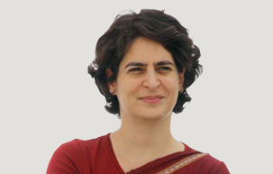
- BJP Candidate list: Narendra Modi will candidate from the Varanasi.
- Sources: In next elections of SSACC Naina Sharma can file Vice President candidate against Mehak Sharma at SSACC.
- “Vice President is quit on regular inspection and disciplinary action against Nishita Jangra, Why?” – Naina Sharma.
- Satya Prakash Sharma written letter to Mannat Sharma and requested to election before the end of tenure.
- SSACC passes resolution that President and Vice President election will held in every two years.
- Congress President supported the movement against Dream 11 Prediction.
- Aam Aadmi Party (AAP) also supported movement against the Dream 11 Prediction.
- “BJP & RSS is dividing India, which is dangerous” – Mannat Sharma.
- “BJP & RSS is danger for this country” – Mannat Sharma.
- Press Release: SSACC announced the names for the ALL INDIA ENVIRNMENT DEVELOPNMENT COMMITTEE OF SSACC. (AIEDC)
- “We are totally against the act by dream 11 Prediction” – Arvind Kejriwal.

HISTORY MOMENTS

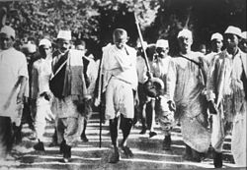DANDI MARCH: MOVEMENT WHICH HAVE CRITICAL INVOLVEMENT IN INDEPENDANCE ERA
NEW DELHI | 12, March 2019

The Salt March, also known as the Dandi March and the Dandi Satyagraha, was an act of nonviolent civil disobedience in colonial India led by Mohandas Karamchand Gandhi. The 24-day march lasted from 12 March 1930 to 6 April 1930 as a direct action campaign of tax resistance and nonviolent protest against the British salt monopoly. Mahatma Gandhi started this march with 78 of his trusted volunteers. Walking ten miles a day for 24 days, the march spanned over 240 miles, from Sabarmati Ashram, 240 miles (384 km) to Dandi, which was called Navsari at the time (now in the state of Gujarat). Growing numbers of Indians joined them along the way. When Gandhi broke the salt laws at 6:30 am on 6 April 1930, it sparked large scale acts of civil disobedience against the British Raj salt laws by millions of Indians.^{[1]}
After making salt at Dandi, Gandhi continued southward along the coast, making salt and addressing meetings on the way. The Congress Party planned to stage a satyagraha at the Dharasana Salt Works, 25 miles south of Dandi. However, Gandhi was arrested on the midnight of 4–5 May 1930, just days before the planned action at Dharasana. The Dandi March and the ensuing Dharasana Satyagraha drew worldwide attention to the Indian independence movement through extensive newspaper and newsreel coverage. The satyagraha against the salt tax continued for almost a year, ending with Gandhi's release from jail and negotiations with Viceroy Lord Irwin at the Second Round Table Conference.^{[2]} Over 60,000 Indians were jailed as a result of the Salt Satyagraha.^{[3]} However, it failed to result in major concessions from the British.
The Salt Satyagraha campaign was based upon Gandhi's principles of non-violent protest called satyagraha, which he loosely translated as "truth-force". Literally, it is formed from the Sanskrit words satya, "truth", and agraha, "insistence". In early 1930 the Indian National Congress chose satyagraha as their main tactic for winning Indian sovereignty and self-rule from British rule and appointed Gandhi to organise the campaign. Gandhi chose the 1882 British Salt Act as the first target of satyagraha. The Salt March to Dandi, and the beating by British police of hundreds of nonviolent protesters in Dharasana, which received worldwide news coverage, demonstrated the effective use of civil disobedience as a technique for fighting social and political injustice.^{[6]} The satyagraha teachings of Gandhi and the March to Dandi had a significant influence on American activists Martin Luther King Jr., James Bevel, and others during the Civil Rights Movement for civil rights for African Americans and other minority groups in the 1960s. The march was the most significant organised challenge to British authority since the Non-cooperation movement of 1920–22, and directly followed the Purna Swaraj declaration of sovereignty and self-rule by the Indian National Congress on 26 January 1930. It gained worldwide attention which gave impetus to the Indian independence movement and started the nationwide Civil Disobedience Movement.
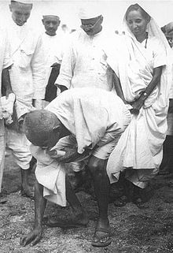
Salt Satyagraha produced scant progress toward dominion status or self-rule for India, and did not win any major concessions from the British. It also failed to attract Muslim support. Congress leaders decided to end satyagraha as official policy in 1934. Nehru and other Congress members drifted further apart from Gandhi, who withdrew from Congress to concentrate on his Constructive Programme, which included his efforts to end untouchability in the Harijan movement. Even though British authorities were again in control by the mid-1930s, Indian, British, and world opinion increasingly began to recognise the legitimacy of claims by Gandhi and the Congress Party for sovereignty and self-rule . The Satyagraha campaign of the 1930s also forced the British to recognise that their control of India depended entirely on the consent of the Indians – Salt Satyagraha was a significant step in the British losing that consent.^{[83]}
Nehru considered the Salt Satyagraha the high-water mark of his association with Gandhi,^{[84]} and felt that its lasting importance was in changing the attitudes of Indians:
Of course these movements exercised tremendous pressure on the British Government and shook the government machinery. But the real importance, to my mind, lay in the effect they had on our own people, and especially the village masses ... Non-cooperation dragged them out of the mire and gave them self-respect and self-reliance ... They acted courageously and did not submit so easily to unjust oppression; their outlook widened and they began to think a little in terms of India as a whole ... It was a remarkable transformation and the Congress, under Gandhi's leadership, must have the credit for it.
More than thirty years later, Satyagraha and the March to Dandi exercised a strong influence on American civil rights activist Martin Luther King, Jr., and his fight for civil rights for blacks in the 1960s:
Like most people, I had heard of Gandhi, but I had never studied him seriously. As I read I became deeply fascinated by his campaigns of nonviolent resistance. I was particularly moved by his Salt March to the Sea and his numerous fasts. The whole concept of Satyagraha (Satya is truth which equals love, and agraha is force; Satyagraha, therefore, means truth force or love force) was profoundly significant to me. As I delved deeper into the philosophy of Gandhi, my skepticism concerning the power of love gradually diminished, and I came to see for the first time its potency in the area of social reform. ****

POINT OF VIEW
ACHIVEMENT OF UPA GOVERNMENT (2004 – 2009) - Nidhi Sharma

After the Congress government led by Prime Minister P.V. Narsimha Rao lost power in elections, the BJP formed the new government. As usual during the non Congress governments, Indian economy once again found itself facing new challenges. Trends of economic slowdown were clearly evident in 1997. It was primarily because of the policies adopted and implemented by the successive governments. The Congress government took decisions that were in the interest of the country and were aimed at fortifying the economy whereas the BJP implemented policies that were meant only for political benefits.
During 1997 98, the growth rate of GDP came down to worrisome 5 % which was 7.8 % in 1996 97. The growth rate in exports sector witnessed a rise of 20 % but it also slipped for the next three years since 1996. The growth rate in exports sector became negative in 1998 99 (April December). Likewise, the industrial development rate decreased a whopping 50%. It was a matter of great concern that even the growth rate of infrastructure sector also slowed down and it impacted the whole system. Foreign capital both in direct investment and in portfolio investment also witnessed a slowdown. The portfolio investment plunged into negative in 1998-99 (April December).
The pressure of fiscal deficit on the economy also multiplied. In 1998-99, the government had to declare in its Economic Survey report that the economic situation had become so grim that it needed a rethinking of constitutional limits

regarding fiscal deficit. It was declared as the need of the hour.
Apart from this, nuclear tests led to economic sanctions on India. It proved detrimental for the Indian economy. The BJP government went ahead with the nuclear tests keeping political advantages in mind. Political instability, coalition government by opportunistic parties, duality in eco-policies of the BJP government, opposing globalization and supporting swadeshi by its parent organization all these factors contributed in slowing down the pace of economic reforms initiated by the Congress govt. During six and half year tenure, the BJP government derailed the Indian economy.
The people of this country well understood the harms inflicted by the BJP government on Indian economy and in 2004, gave the mandate to the Congress once again. The UPA government was formed under the leadership of the Congress Party. The Congress president Sonia Gandhi was nominated as the chairperson of the UPA who presented an unparalleled example of renouncement by humbly rejecting the post of prime minister. She proposed the name of Dr. Manmohan Singh for the post of prime minister. India once again began to march on the path of progress under the leadership of Dr. Manmohan Singh and Congress and UPA president Smt. Sonia Gandhi.
First of all the UPA government under the Guidelines and directions from the UPA chairpersons Smt. Sonia Gandhi started working for the Economic growth of the country. The average rate of economic growth during the self declared India Shining period of the BJP was just 5.8 % per year’s compared to 8.5 % during the five year tenure of the Congress lead UPA government. Under the leadership of the Prime Minister Dr. Manmohan Singh despite two global slowdowns the average GDP growth during the period of UPA government has been 7.7 % and per capita income UPA government and India become the third highest economy.
The GDP of India increased to 100.28 lakh crores from 32.42 lakh crore in 2004-05 per capita Income went up to Rs. 68747 in 2012 from Rs. 24143 in 2004. The average Fiscal Deficit of UPA was 4.6 % while under the previous government under the previous BJP led NDA government it was at 5.5 %. This is very surprising to know that the average yearly FDI inflow under the UPA government was USD 20.22 billion, on the contrary, previous NDA government’s was USD 2.85 billion.
Infact India’s GDP growth rate under UPA was always 8 % + from April, 2004 till mid 2010, except for a dip during up the global recession, when the credit dried up and for the times the BJP started stalling parliament. Congress party leadership has always acknowledged the important role of the Smt. Sonia Gandhi as a chairperson of the UPA had instructed the government to facilitate this sector. Prime Minister Dr. Manmohan Singh and the Finance Minister of India made many policies and took several steps to strength this sector.
on 29 February, 2008 the UPA government announced a relief package for farmers which included the complete waiver of loans given to the small and marginal farmers, called the Agriculture Debt waiver and Debt Relief Scheme, the 600 billion rupee package included the total value of the loans to be waived for 30 million small and marginal farmers (estimated at 500 billion rupees) and a onetime settlement scheme (oTS) for another 10 million farmers (estimated at 100 billion rupees). During the financial years 2008-09 the debt waiver amount rose by 20 % to 716.8 billion rupees and the overall benefit of the waiver and the oTS was extended to 43 million farmers. In most of the Indian states the number of small and marginal farmer’s ranges from 70 % to 94 % of the total farmers.
Under the leadership of UPA chairperson Smt. Sonia Gandhi and PM Dr. Manmohan Singh, UPA government launched the flagship “Rashtriya Krishi Vikas Yojana” in 2007 to reorient the agriculture development strategies to meet the needs of farmers. Similarly the farmer’s participatory system of need production was given an impulse under the seed village scheme by organizing more than 6500 seed villages. Considering Agriculture credit as the driver of agriculture production the Budget 2013-14 proposed to increase the target to Rs. 700,000 crores from 575000 crores. During UPA government the interest subvention scheme for short-term crop loans on time will be able to get credit at 4 % annum. Nutrient based subsidy policy for all fertilizers other than urea was introduced.
Supported by these pro-farmer policies the production of foodgrains in India hit the all time record level of over 250 million tones with production of rice and wheat estimated at all time record levels of 102 million tons 88 million tons respectively. During that’s period the production of pulses and oil seeds was 17.28 million tons and 30.53 million tons respectively. India continued to be the largest milk producing nation in the world. Considering this fact the UPA government approved the National Dairy Plan Phase-I to be implemented during the period 2011-12 to 2016-17. The scheme was being implemented for increasing productivity of milch animals.
Under the guidelines of UPA chairperson Smt. Sonia Gandhi and leadership of PM Dr. Manmohan Singh another major achievement of the UPA government was that it doubled the electricity production in India from 1,12,700 MW in 2004 to 2,34,600 MW in 2014. A capacity of 54964 MW added in the 11th plan which has a significant contribution from the privates sector. The success of the government’s international Civil Nuclear initiatives was manifest in the highest ever generation of electricity from nuclear power during the year 2011 at 32,455 million units. India under UPA signed Civil Nuclear Agreements with record number of countries. Russia, France, Germany, U.K., U.S., South Korea and Mongolia. Similarly, India emerged as a leader in Asia and holds 4th rank worldwide in wind power.
Since its inception quality education has been a prime objective of the Congress party and its visionary leader. Due to the right to education by the UPA government India has achieved “near universal education” at the primary school level and the dropout rates have also decreased. The outlay for education has been constantly increased the outlay for education has been constantly increased. There has been about 99 % enrolment at Primary Level education. Literacy rate in India is now 74 %. This is a substantial increase from the figures, 10 years ago, ushered by social Revolution by UPA. Gross enrolment in higher education, which was 12.3 % in 2006-07, had gone up to 18 % in 2011-12. UPA government also led to massive expansion in Higher Education 7 New IIM’s, 8 New IIT’s and 10 New NIT’s were established.
UPA government supplied free text books to 9.94 crore children in 2012 and uniforms to all girls, SC, ST and BPL children had been provided for 504.83 lakh children 10.54 crore children studying in 12.31 lakhs institutions were provided Mid Day Meal.
Apart from these major achievements in education sector 16 new central universities and 2 new school of Planning and Architecture and 6 new Law Universities were also established by the UPA government.
Congress party, its senior’s leaders and Congress governments always has a concern about the public health. Smt. Sonia Gandhi knew that the previous NDA government had ignored this issue of major concern, she instructed the UPA government to take appropriate measures to improve this sector. So the UPA government under the leadership of Dr. Manmohan Singh worked with zeal and devotion to improve public health. Since the launch of the National Rural Health Mission over 1.57 lakh personal have been added to the health system during 200512. Over 8.6 lakh Asha’s appointed to act as bridge between the communities and the health facilities in villages. A total of 70,000 beds have been increased in government health institutions and provision of essential and emergency facilities. The UPA government strengthened the infrastructure by taking up 594 District Hospital, 2721 community Health centers, 5459 Primary Health Centers and 31001 Sub-Centers for new constructions or renovations.
Under the leadership of UPA chairperson Smt. Sonia Gandhi the UPA government created a separate Ministry as the Ministry of women and Child Development with effect from 30 January, 2016. The UPA government also introduced protection of children from sexual offences Act 2012 and under Integrate Child Protection Scheme 548 Child Welfares Committees and 561 Juvenile Justice Boards were establish. Under the leadership of Dr. Manmohan Singh the National Mission for Empowerment of women was launched by the then government of India in 2010. Similarly UPA government established sexual Harassment of women at workplace Act on 26th February, 2013.
Under the leadership of UPA chairperson Smt. Sonia Gandhi and PM Dr. Manmohan Singh UPA’s India cut poverty at the fastest rate in its history by moving 138 million above the same poverty time used by the World Bank. This was under the Congress led UPA rule from 2004-05 to 2011-12. The UPA started the Mahatma Gandhi National Rural Employment Guarantee Act (MGNREGA) in 2006 which is the largest welfare scheme of its kind in the world because removal of poverty has been the prime concern of the Congress party. MGNREGA has special role in helping the poor and downtrodden to earn a living in an honorable way. MGNREGA initially covered 200 districts in 27 states to provide guaranteed employment to rural households for 100 days. In 2008 the UPA government extended the coverage of the scheme to all the districts of the country. In the following 6 years, an amount of Rupees Two Lakh crores was allocated under MGNREGA the scheme now benefits 34.30 crore poor households providing them with employment.
The implementation of MGNREGA provided an opportunity to strengthen democratic process. Panchati Raj institutions have a key role under the Act. Gram Sabhas, sub help groups, local monitoring committees, beneficiary groups and other farms of community organizations are the basic agencies which have to run and monitor the programme. This presents an enormous step towards the empowerment of vulnerable sections of the society. It helped the poor to fight poverty, disease and ineptness. MGNREGA is a unique social security system. It confers upon groups the right to demand work when they need it. This scheme was especially made for Scheduled Castes, Scheduled Tribes, for poor women, who are the worst sufferers of social inequality. MGNREGA is the gift of UPA to our people to assist them to fight poverty.
After the rural job guarantee programme the UPA government started food security for nation’s two third populations the right to 5 Kg. of food grains every month at highly subsidized rates of Rs 1-3 a Kg. however, about 2.43 poorest of the poor families covered under the Antyodaya Anna Yojana Scheme under PDS (Public distribution System). Would get legal entitlement to 35 Kg of foodgrains per family per month, infect there was a threefold increase in food subside during UPA tenure. As a result of these policies there was an average decline in poverty at two percent per annum.
UPA is the only government is Modern India to pass the historic right to information Act, 2005 to usher in transparency in governance through citizen participation RTI Act has empowered lakhs of individuals and have made the state responsible. A revolution has taken place ever since and people have become more aware of their rights and procedures. This is also very interesting to know that UPA government was the first government is India to present a white paper on Black money in May, 2011. The UPA government also introduced UID to more than 51 crore Aadhar cards giving people access to direct benefit transfer to individual beneficiaries of various social sector scheme.
If we examine the UPA government’s achievements critically, we come to some very satisfactory conclusions such as India’s national growth rate of GDP dipped from 6.25 % to 5.93 % during NDA and recovered to 8.47 % thereafter. India’s per capita income in 2004-05 was Rs. 24,143 that was increased to Rs 68,747 in 2012-13. The UPA government issued 12.70 crore job cards under MGNREGA in 2012-13 while in 2006-07 is 3.7 crore job cards were issued.
Actual expenditure on Minority Scheme had been from 143.53 crores in 2006-07 to Rs. 1593.23 in 2012-13. Internal security improved and the growth rate in north-eastern region was higher than national average. Northeast growth rate was 9.9 percent compared to national average of 7.4 %. The expenditure on Sarva Shikhsha Abhiyan was Rs. 2370 crores in 2003-04 that was brought to 2084 crores in 2011-12. The gross enrolment ratio in Primary school increased from 98.3 % in 2003-04 to 116 % in 2010-11. Similarly, the gross enrollment ratio in secondary school increased from 62.5 % in 2003-04 to 85.5 % in 2011-12.
The expenditure on country’s defence constantly increased. Under the UPA government it was over 2 lakh crores. Expenditure on mid day meal was Rs. 1325 crore in 2003-04 that was 9890 crore in 2011-12. More than 2 lakh kilometers of new roads were added to the rural road network in 9 years. Similarly, the annual passengers originating for Indian Railways increased from 5.1 crores in 2003-04 to 8.2 crores in 2011-12. Indian exports in drugs and pharmaceutical increased to all time high figure of Rs. 63,347 in 2011-12, while they were 15,213 crores in 2003-04. The rate of unemployment came down to 6.6 % in 2009-10 which was 8.2 % in 2003-04.
POINT OF VIEW
These facts prove that under the leadership of UPA chairperson Smt. Sonia Gandhi and UPA government led by PM Dr. Manmohan Singh, the country was on the right track of rapid growth and this tenure of Congress led UPA government was a saga of success.

NO JOBS TILL NOW

According to statistics released by the Labour Bureau, job creation or job growth for 2015 and 2016 (April-December) stood at 1.55 lakh and 2.31 lakh in numbers respectively. These numbers are less than 1% of the 2 crore jobs promised per year by PM Modi.
In the 2016 survey of the Labour Bureau, it was found that in most of the eight biggest employment generation sectors — textiles, leather, metals, automobiles, gems and jewellery, transport, information technology and handlooms — jobs were shrinking.
The job situation was already grim when PM Modi announced demonetisation, an ill-advised policy decision that served as the coup de grace for job growth in India.
Estimates suggest around 2 crore jobs were lost in the immediate aftermath of 'notebandi' and the shoddy roll-out of the Goods and Services Tax (GST).
Farmers too were badly hit by demonetisation, according to a report submitted by the Union Agriculture Ministry to the Parliamentary Standing Committee on Finance.
The impact of demonetisation on agricultural jobs has been so severe that the Centre has purportedly stopped releasing farmer suicide numbers since 2016.
In 2018, the job creation situation is especially dire.
As many as 11 million Indians lost their jobs during 2018, a report by the Centre for Monitoring Indian Economy (CMIE) said. The number of employed recorded in December 2018 was at 397 million, which is 10.9 million less than the figure of 407.9 million seen a year ago at the end of December 2017.
If this was not bad enough, a report released in September 2018 by the Centre for Sustainable Employment of the Azim Premji University confirms that the rate of unemployment in India is at the highest in 20 years.
This shortage of jobs is compounded by depressed wages, with 82 per cent of men and 92 per cent of women earning less than Rs 10,000 per month.
One could perhaps have forgiven the Modi government’s dismal failure to create jobs if they had tried and failed. What is inexplicable is that the government has displayed no apparent intent to fill existing vacancies.
Over 10 lakh vacancies for teachers in elementary and secondary schools exist at the moment. A question answered in the Lok Sabha in March 2018 citing numbers from the Bureau of Police Research & Development stated that there are 4.4 lakh vacancies in civil and district armed police. It added that an additional 90,000-odd posts are vacant in the state armed police, taking the total vacant positions in police forces to 5.4 lakh across the country.
Why is the government apparently making no attempt to fill these vacancies when India is at the cusp of one of the biggest unemployment crises since Independence?
In order to guarantee the ‘right to work’ for every Indian, the UPA government had enacted the Mahatma Gandhi National Rural Employment Guarantee Act (MGNREGA) in 2005. PM Modi has been vocal about his criticism of the Act — does he not want to guarantee employment for the poor?
Earlier this month, a letter to the PM, prepared by senior activists, led by Aruna Roy on behalf of the Peoples’ Action for Employment Guarantee (PAEG), and signed, among others, by 80 members of Parliament, states that despite repeated public statements by the government promising employment, the MGNREGA “is being systematically undermined”. The letter includes an analytical note on the working of the MGNREGA, which says that more than 99 per cent of MGNREGA funds have been exhausted, and no additional funds have been sanctioned.
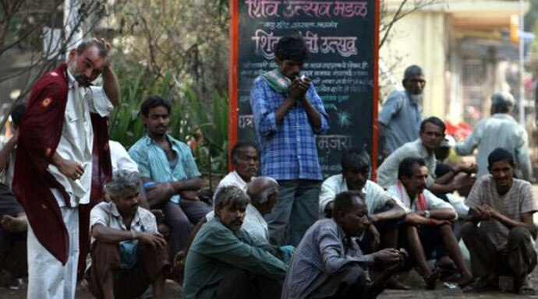The facts are clear. Yet, during the no-confidence motion in the Lok Sabha last year, PM Modi reportedly said that over 1 crore jobs were created in the country over the past year. He apparently cited EPF data to support his claims. This claim was reportedly refuted by the Chief Statistician of India, Pravin Srivastava, who said that EPFO data should be seen as a proxy for formalisation, not employment creation.
The government later admitted to a Parliamentary panel that it has no real data on the number of new jobs created since 2014. So, where did the figure above come from?
The sentiment that PM Modi has failed miserably in creating jobs has been echoed even by senior BJP leaders.
In 2018, when Union minister Nitin Gadkari was asked a question on reservation in jobs, he replied: “Even if reservation is given, there are no jobs”.
While campaigning for the Rajasthan Assembly elections last year, then-CM Vasundhara Raje, when asked about the growing incidents of mob lynchings in the state, commented that ‘lynchings were a result of lack of jobs’.
The failure of this government to generate employment has been proven beyond doubt. What is very worrying is the growing evidence that there was apparently never any serious intention to create jobs in the first place.
In 2014, it was jumlas that brought the BJP to power. In 2019, it will be jobs that will lead to their undoing. ****

REPORT



DREAM 11: A DARK LIGHT FOR UPCOMING FUTURE
  - ALL INDIA COMMITTEE FOR RESERCH & ANALYSE OF SSACC (AICRA)

AICRA had launched new report for the Dream 11 which is platform responsible for the moaning of the Youth Childrens in the gambling. The report gives the brief details about the game and the involvement. The point should be notice that SSACC President Mannat Sharma and Delhi CM Arvind Kejriwal supported this movement.
The report says the following details:
- This game provides a wide range of gambling platform for under 18 childrens which is legally offence.
- Under 18 Childrens easily make their fake Email address and easily access in this game.
- Game provide real money to the childrens on accessing in this gambling platform.
- The moaning of money is done by the payment wallets & throw bank accounts.
Even we know the details in nower days even every child or person can make their fake account on mail and also on the Online Wallets without KYC (Know your Customer). These increasing offence and involvement in the Gambling platform is very sad and not good for upcoming future generation. Many childrens are involving in bad habits via this.
The users of the Dream 11 also increasing day by day. In burea by the Dream 11 the increasing value of the users of Dream 11 can be seen. In 2014 the users are 10 Lakh, in 2016 it is 50 Lakh and in last 2018 it is 2Crore. Means it is rapidly increasing.

The following data shows increasing users of the Dream 11. In this data of 2018 their is 29% young generation who are less than 18 years. SSACC President Mannat Sharma written letter to Home minister Rajnath Singh informing about this legal offence, But, their is no reply by Government and responsible authorities. But, recently SSACC President written letter to Delhi CM Arvind Kejriwal regarding ban of Dream 11 Prediction. The letter was self explanatory. SSACC President written in his letter that think as the CM of Delhi you are on constitutional post not as politician. Mannat Sharma requested CM of Delhi to be with this movement.
CM of Delhi Arvind Kejriwal given orders to their officers to write letter to MHA (Ministery of Home Affairs) for taking sudden action on this game. CM Kejriwal look very quit concentrative on this issue.
In certain letters SSACC demands following from the Government of India:
- We want that this game should ban.
- If ban cannot be imposed so, the security should increased.
- This increased security should contain the identity verification.
- Every person who is signing up in this game should above 18 years and have to be verified by their identity proof attachment.
- The payment to person must given to the persons account who is in majority in age and who had been verified by their details.
- The security increasing will led to stop accessing under 18 people via creating fake email ids.
- If these cannot be implemented so, game should be ban.
- Note: This game is already banned in Assam, Orrisa & Telengana.
LEGALITY
In 2017, a case was registered against the company in an Indian High Court. The court, in its ruling, stated that playing the Dream11 game involves superior knowledge, judgement and attention. The Court also held that ‘the element of skill’ had a predominant influence on the outcome of the Dream11 game. However, the law does not allow Fantasy Sports in few Indian States like Assam, Odisha and Telangana.
A challenge to this judgement was filed with the Supreme Court of India, which dismissed the appeal. The judgement provided legality to the company and allowed them to run their operations throughout the country.
Despite it being adjudged to be a "game of skill", experts believe that the company operates in the country's regulatory "grey area".

USERS INVOLVEMENT
We must know that how many childrens involved in this 2 Crore childrens.

This graph shows that on 2 Crore 5800000 are involved childrens but, it is only an report it can be increased. But, we can say with proof that it will not will down it can increase with 37% which is big number.
According to experts it is notable that in year 2019 these 2 Crore must be double as per game is gaining popularity. The increasing usage of game is leding to destruction in our society.
So, Be Aware ****

NATURE DIARY

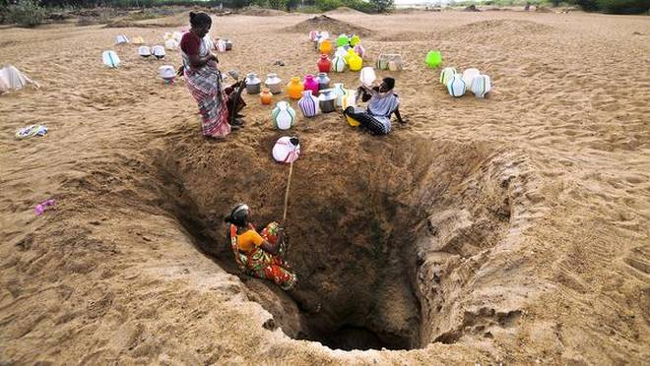

WATER: AN IMPORTANT RESOURCE
Source: UNICEF (Water in India)

India is the second most populated country in the world with over 1.2 billion people (Census of India, 2011). Water in India is intricately intertwined with the cultural fabric of the country, and has both economic and social connotations. Several attempts have been made to estimate the country's available water resources and the total estimated water budget varies considerably. Official estimates of the Ministry of Water Resources (MoWR) have put total utilisable water at 1,123 4 billion cubic metres (BCM) as against the current use of 634 BCM, reflecting a surplus scenario (Planning Commission, 2010). Narsimhan (2008) calculated the water budget using an evapotranspiration rate of 65 per cent as against 5 the 40 per cent used in official estimates. The utilisable water for human use thus comes out to be 654 BCM, which is very close to the current actual water use estimate of 634 BCM reflecting an alarming situation (ibid.). Table 1.1 gives the comparative picture of the water budget as per the two estimates. It is pertinent to note that there exists a considerable temporal and spatial variation within the country with respect to water availability. For instance, the Ganga-Meghna-Brahmaputra basin covers a land area of 33 per cent and accounts for 60 per cent of India's water resources, while the catchment of rivers flowing west is 3 per cent and they account for 11 per cent of the country's water resources. Therefore, 71 per cent of India's water resources are available to only 36 per cent of the area while the remaining 64 per cent has 29 per cent available (Verma and Phansalkar, 2007). Various estimates point to a widening gap between water demand and supply in the future. For example, in the base case scenario developed.
by 2030 by the Water Resources Group, India faces a large gap between current supply and projected demand, amounting to 50 per cent of demand or 754 BCM (Addams et al., 2009). Critiques argue that the way in which India's water budget has been calculated, is highly aggregated and gross which does not lead to much of decision making. Garg and Hassan (2007) reveals that the assessment of utilisable water resources of India are overestimated to the range of 66 to 88%. The authors estimate the utilisable water resources as 668 BMC, much less than the estimates of CWC, NCIWRD and National Water Policy of India. The report of the working group on water database development and management for the 12th five year plan (2012-2017) by the planning commission documents the historical account of this. “In the 1950's, A.N. Khosla, who headed the then newly constituted Central Water and Power Commission (CWC), used an empirical equation relating surface run-off to rainfall and evaporation (postulated as a function of temperature) to estimate average annual water resources potential in six regions. Subsequently, the CWC sought to assess the water resources potential in major basins. Studies based on statistical analysis of flow data wherever available and rainfall–run-off relations were done for 23 basins and sub-basins between 1952 and 1966, and for some major peninsular rivers and the Ganges and Brahmaputra basins during the 70s. At that time the needed data on rainfall, terminal discharge observations, and validated rainfall–surface flow relationships were limited. In the early 90s, the conceptual framework for assessing water resources availability for several basins was refined on the basis of observed outflows at the terminal site for upstream extraction of surface water, reservoir evaporation and return flows, and taking explicit account of the contribution of groundwater recharge and interactions between surface and groundwater. For some large basins, estimates adopted by tribunals ((Narmada, Godavari, Mahanadi and Cauvery) and those based on special studies (Ganges and Brahmaputra) were used. Subsequent reviews by the National Commission for Integrated Water Resources Development (NCIWRD) and an internal group of the CWC followed the same procedures and more or less endorsed the 1993 estimates of the country's water potential. In any event, the estimates of overall water resources potential for the country made at different times have remained more or less the same. The CWC is currently engaged in a joint project with National Remote Sensing Centre (NRSC) to develop and test a water balance approach using remote sensing data for assessing overall water potential in two basins. It is also important to undertake rigorous analysis of rainfall–run-off relations in different regions using up-to-date data, ensuring that estimates of upstream extractions are based on reliable measurements, conducting systematic surveys to determine the magnitude of groundwater actually pumped, consumption for various non-agricultural uses, and other components of the balance equation. Estimates of overall water resources potential cover both surface flows and groundwater. Though these two sources are interrelated, estimates of their individual contributions, both overall and to utilizable volumes, are made independently by the CWC (for surface water) and the CGWB (for groundwater). Since interactions between these sources are significant, the sum of these two estimates cannot be taken as a measure of the total volume of available and utilizable water resources. It is essential that this exercise be done jointly by these two bodies.” (Planning Commission, 2011: ii-iii) According to the National Environment Policy (NEP) 2006: “India's freshwater resources comprise the single most important class of natural endowments enabling its economy and its human settlement patterns. The freshwater resources comprise the river systems, groundwater, and wetlands. Each of these has a unique role and characteristic linkages to other environmental entities. (MoEF, 2006: 28)” The following section provides a brief overview of the available water resources and related issues. We begin with an overview of rainwater, and then move onto surface and groundwater resources. The long-term average rainfall for the country is 1,160 mm, which is the highest in the world for a 6 country of comparable size. Owing to physiographic factors, rainfall in India is highly variable. For example, in 2008, rainfall measured from about 500 mm in east and west Rajasthan to 3,798 mm in coastal Karnataka (CWC, 2010). India ranks first among rain-fed agricultural countries in terms of both extent (86 Mha) and value of produce (Amarsinghe and Sharma, 2009). More than 80 per cent of the annual run-off of the rivers occurs in the monsoon months of June to September, often causing floods. However, acute water shortage is faced in many parts of India during the rest of the year. Even in areas such as Cherrapunjee in Meghalaya, where there is surplus rainfall, the soil may not be able to retain the water for long thereby 1.2 Water Resources 1.2.1 Rainwater 7Cited in World Bank (2005: 15) 3 River basin 321289 861452 194413 41723 73.3 525 537.2 48.4 Indus Ganga-Brahmaputra-Meghna a. Ganga b. Brahmaputra c. Barak & others Catchment area (Sq.Km) Average Water Resources Potential (BCM)* Table 1.2: Water Resources Potential of River Basins of India causing water scarcity (Bandyopadhyay et al., 1998). In India, rain-fed agro-ecologies contribute 56.7 per cent of the net sown area, 40 per cent of the foodgrain production, and 66 per cent of the livestock. About 85 per cent of coarse cereals, 83 per cent pulses, 42 per cent rice, 70 per cent oilseeds and 65 per cent cotton are cultivated as rain-fed (CRIDA, 2011: 31). In addition, they are substantial means of providing livelihood, income, employment and environmental security. During 1985-95, the growth rate in un-irrigated areas was higher than that of irrigated areas. A study by Bhatia 7 (2005) showed that the crop yield per hectare from irrigated land was consistently much higher than the yield from rain-fed agriculture.
As shown in Figure 2.1, the domestic water demand in India has remained low and accounted for 7 per cent of the annual freshwater withdrawal in 2010. It is pertinent to note that as much as 80 per cent of the domestic water requirement is met by groundwater (World Bank, 2005). The water crunch is felt the most during the critical summer months when many areas suffer from severe water shortages. The Government of India (GoI) has an ambitious scheme of providing piped drinking water to all uncovered habitations by 2012 under the Bharat Nirman Yojana. The programme was launched in 2005. Phase I of the programme was implemented in the period 2005-06 to 2008-09.Phase II is being implemented from 2009-10 to 2011-12. Rural drinking water is one of the six components of Bharat Nirman. During the Bharat Nirman Phase – I period, as per the official monitoring figures 55,067 un-covered and about 3.31 lakh slipped-back habitations were to be covered with provisions of drinking water facilities and 2.17 lakh quality-affected habitations were to be addressed for water quality problem. According to the Eleventh Plan document of the Planning Commission (2008), though more than 95 per cent coverage was achieved prior to Bharat Nirman, out of the 1.422 million habitations covered in the country, about 0.16 million have slipped back to a position where people do not have adequate water to drink and have to walk more than 2 km to fetch potable water. Similarly, about 0.18 million habitations are dependent on contaminated water supply, thereby exposing themselves to water induced diseases (ibid.). Improved water coverage for urban and rural areas till the year 2008 is given in Figure 2.1. It is notable that while the total coverage figures are satisfactory, the coverage with respect to household connections is a matter of concern. Further, a comparative analysis of the improved drinking water coverage over eight years (2000-08) reveals that in urban areas the coverage in terms of household connections has actually declined (see Figure 2.3). The same holds true for rural areas in 2005-08.2000 to 2008, the overall household connections have almost been stagnant. In urban areas, where household connections have actually declined, there could be two issues which explains this; an increase in population leading to household connections not been able to keep pace with the rising population every year, and there could be slip-back due to groundwater depletion and water quality issues.
In terms of sanitation services, Figure 2.3 shows that in urban India an estimated 18 per cent of the population still do not have access to any kind of toilet facility (WHO-UNICEF, 2010). In rural areas, the scale of the problem is particularly daunting, as 69 per cent of the rural population still defecates in the open (ibid.). While building the physical infrastructure is accorded priority for increasing sanitation coverage, it will have to be accompanied by increasing water availability for achieving the real targets, including safe waste disposal. It is estimated that around 37.7 million Indians are affected by waterborne diseases annually, 1.5 million children are estimated to die of diarrhoea alone and 73 million working days are lost due to waterborne diseases each year (Khurana and Sen, 2007)There is a wide variation in the estimation/reported slum population by various government and other agencies. The Census of India 2001 reported a slum population of 42.6 million from 640 towns of the country which was 14.88 per cent of the total census population (it did not include towns with a population below 50,000 and few town and cities with populations of more than 50,000 where local bodies did not recognise any slum area). Later, it also included towns with populations between 20,000-50,000 and reported slum populations of 52.4 million from 1,743 cities/towns. The reported slum population was less than the Town and Country Planning Organization's (TCPO) estimated slum population of 61.8 million. The UN population report estimated a 158.42 million slum population was less than the Town and Country Planning Organization's (TCPO) estimated slum population of 61.8 million. The UN population report estimated a 158.42 million slum population in 2001 (Ministry of Housing and Poverty Alleviation, 2010).
Ministry of Housing and Poverty Alleviation, Government of India in 2008) estimated a 75.26 million slum population in 2001 and projected that slum populations would reach 93.05 million by 2011 (which is about 25 per cent of the provisional population of 2011). Further, UN-HABITAT estimated the slum population at 169 million in 2004-5 (Ministry of Health and Family Welfare, 2009). Although the 11th Five Year Plan (2007-12) considered the census slum population (42.6 million, 14.88 per cent) but it is also mentioned in the document that 'almost 30–40 percent of India's urban population lives in slums' (Planning Commission, 2008). According to the Census of India 2001, there were 498 Class I and 410 Class II cities in the country; the estimated total population of these cities in 2008 was 257.75 million and total water supply was 48090.88 MLD. Average per capita water supply in Class I and Class II cities was 179.02 and 120.79 l per day (CPCB, 2009). Water supply is not uniform across all states or cities. The average per capita water supply for Class I cities of Tamil Nadu is 79.9 l and for Maharashtra, it is 310.09 l whereas the average per capita per day water supply for Class II cities of the state is 106.74 l. Among the Class II cities of Maharashtra, water supply ranges between 34.5 LCPD in Malkapur to 464.94 LCPD in A n j a n g a o n . S u c h variations are common across all the cities and states of the country. One of the major reasons for wide variation in per capita water supply is the mismanagement of the water supply system. Levels of system losses through 'unaccounted-for water' or 'non-revenue water' are often as high as 50 per cent in Indian cities and represent large financial and environmental losses to cities and their economies. A UN-HABITAT supported study for four cities of Madhya Pradesh has revealed that this Non-Revenue Water (NRW) ranged between 31 per cent and 49 per cent in Bhopal, between 37 per cent and 43 per cent in Jabalpur, and between 36 per cent and 66 per cent in Gwalior. Based on the study, city-specific water demand management
strategies were developed to minimise water losses and to increase revenue for municipal corporations (UN-HABITAT, 2006). Discharge of untreated sewage is the most critical water polluting source for surface and groundwater in India. Estimated sewage generation from Class I and Class II cities is about 38,000 million l per day (80 per cent of the water supply) and only 31.5 per cent of the generated sewage can be treated per day on the basis of the installed capacity. Estimated sewage generation by Class I cities is 35,558 MLD and sewage treatment capacity is only 32 per cent of the total sewage generated. Estimated sewage generation from Class II cities is about 2,697 MLD and the treatment capacity is only 8 per cent of the generation. Thus, 70 per cent of untreated sewage from Class I cities and 92 per cent from Class II cities contaminates surface and groundwater on a daily basis
The census 2011 data shows that 18.6 percent households in urban India do not have latrines within the premises. 6 percent urban households use public latrines.32.7 percent Pour flush latrine in urban areas connected to sewer pipes. At the same time, pour flush latrine connected to a septic tank is recorded in 38.2 percent of households.It is reported that 95 per cent of urban households have access to improved source of water (NFHS-III, 32 2005-6) and access to improved source of water is not a reflection of availability of safe drinking water. It is also reported that about 78 per cent of India's urban population has access to safe drinking water (CPCB, 2009)
For More Report visit:
http://www.indiaenvironmentportal.org.in/files/file/water
REMEMBERING IDEAL

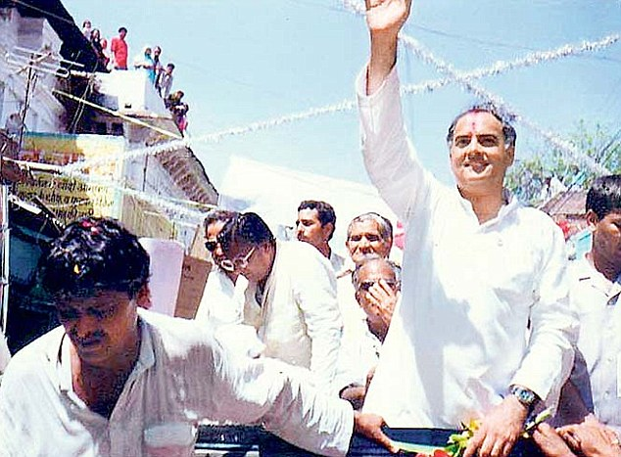

REMEMBERING RAJIV

At 41, Rajiv Gandhi was the youngest Prime Minister of India and perhaps one of the youngest elected heads of Government in the world. His mother, Indira Gandhi, was eight years older when she first became Prime Minister in 1966. His illustrious grandfather, Jawaharlal Nehru, was 58 when he started his 17 year long innings as free India’s first Prime Minister.

Besides being the harbinger of a generational change in the country, Mr. Gandhi received the biggest mandate in the nation’s history. In the elections to the Lok Sabha, which he ordered as soon as the mourning for his slain mother was over, the Congress party got a much higher proportion of the popular vote than in the preceding seven general elections and captured a record 401 seats out of 508.

Such an impressive start as the leader of 700 millions Indians would have been remarkable under any circumstance. What makes it even more so, indeed unique, is that Mr. Gandhi was a late and reluctant entrant into politics even though he belonged to an intensely political family that served India for generations, both during the freedom struggle and afterwards.

He was born on August 20, 1944, in Bombay. He was just three when India became independent and his grandfather became Prime Minister. His parents moved to New Delhi from Lucknow. His father, Feroze Gandhi, became an M.P. He earned a reputation as a fearless and hard working Parliamentarian.

Rajiv Gandhi spent his early childhood with his grandfather in the Teen Murti House, where Indira Gandhi served as the Prime Minister’s hostess. He briefly went to school at Welham Prep in Dehradun, but soon moved to the residential Doon School in the Himalayan foothills. There he made many lifelong friendships and was also joined by his younger brother, Sanjay.

After leaving school, Mr. Gandhi went to Trinity College, Cambridge, but shifted to the Imperial College, London, soon enough. He did a course in mechanical engineering. He really was not interested in “mugging for his exams”, as he was to say later.

By this time it was clear that politics did not interest him as a career. According to his classmates, his bookshelves were lined with volumes on science and engineering, not works on philosophy, politics or history. Music, however, has had a place of pride in his interests. He liked Western and Hindustani classical music as well as modern music. Other interests included photography and amateur radio.

His greatest passion, however, was always flying. No wonder then that on returning home from England, he quickly passed the entrance examination to the Delhi Flying Club, went on to obtain a commercial pilot’s licence and soon became a pilot in Indian Airlines, the domestic national car rier. 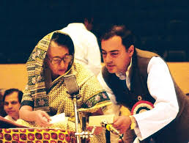.

While studying at Trinity College, he met a young Italian student studying English at the Bell Educational Trust's language school in the city of Cambridge, named Edvige Antonia Albina Màino. He would later marry her in a Hindu Ceremony in New Delhi in 1968. Rajiv Gandhi and his wife, now known as Sonia Gandhi, stayed in Smt. Indira Gandhi’s residence in New Delhi with their two children, son Rahul and daughter Priyanka. Theirs was a very private life despite the surrounding din and bustle of political activity.

But Sanjay’s death in an air crash in 1980 changed all that. The pressure on Mr. Gandhi to enter politics to help his mother, then besieged by many internal and external challenges, grew. He resisted these pressures at first but later bowed to their logic. He won the by-election to Parliament, caused by his brother’s death, from Amethi in U.P. The Constituency returned to him by a whopping margin that too has become a national record.

For no one could have ascended to power—becoming both Prime Minister and Congress President—in more tragic and tormenting circumstances than Mr. Gandhi did in the wake of Indira Gandhi’s brutal assassination on 31 October, 1984. But he wore the awesome burden of personal grief and national responsibility with remarkable poise, dignity and restraint.

Congress lost the 1989 elections and Mr. Gandhi became the leader of the opposition. The National Front collapsed in early 1991 and elections were announced in May, 1991. He died in a tragic bomb blast on 21st May, 1991 at Sriperumbudur in Tamil Nadu.

A modern-minded, decisive but undemonstrative man, Mr. Gandhi was at home in the world of high technology. And, as he had repeatedly said, one of his main objectives, besides preserving India’s unity, was to propel it into the twenty-first century.****

TRIBUTES

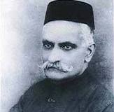
JAMSETJI TATA
Indian Industrialist
3rd March, 1839 – 19th May, 1904
MOTILAL NEHRU
Famous Indian Freedom fighter
6th May, 1861 – 6th Feb, 1931

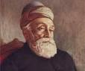
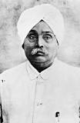
LALA LAJPAT RAI
Indian freedom fighter
28, January 1865 – 17, November 1928
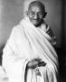
MOHANDAS KARAMCHAND GANDHI
Father of nation
2, October 1869 – 31, January 1948
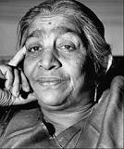
SAROJINI NAIDU
Freedom Fighter of India & First women president of Indian National Congress
13, February 1879 – 2, March 1949

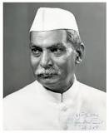
RAJENDRA PRASAD
First President of India
3, December 1884 – 28, February 1963

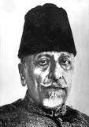
ABUL KALAM AZAD
Senior Leader, Indian national Congress
11, November 1888 – 22, February 1958
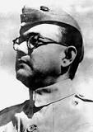
SUBHASH CHANDRA BOSE
Indian Freedom fighter
23, January 1897 – 18, Augest 1945
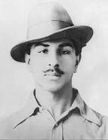
BHAGAT SINGH
Indian Freedom Fighter
28, September 1907 – 23, March 1931
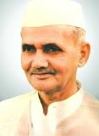
LAL BAHADUR SHASTRI
Former Prime Minister of India
2, October 1904 – 11, January 1966

A work on Dream 11 by THE YOUTH INDIA is fantastic

Dheer Singh
Sonipat, Haryana
Peoples voice is hiding by the Government of India on Dream 11.
Aware & Rise Government is Sleepy
Niranjan
Orissa
LETTERS TO EDITOR

PM Modi had no good policy
One thing is good in him that he give excellent Speech
Priyanka
Delhi
Lets build progressive India with SSACC
I have experience
H.S. Bhatia
Volunteer, SSACC
Mumbai

Way to Write to Editor
To,
The Editor,
The Youth India,
373, Shahpur Jat
New Delhi - 110011

